Liverpool Christmas Concert
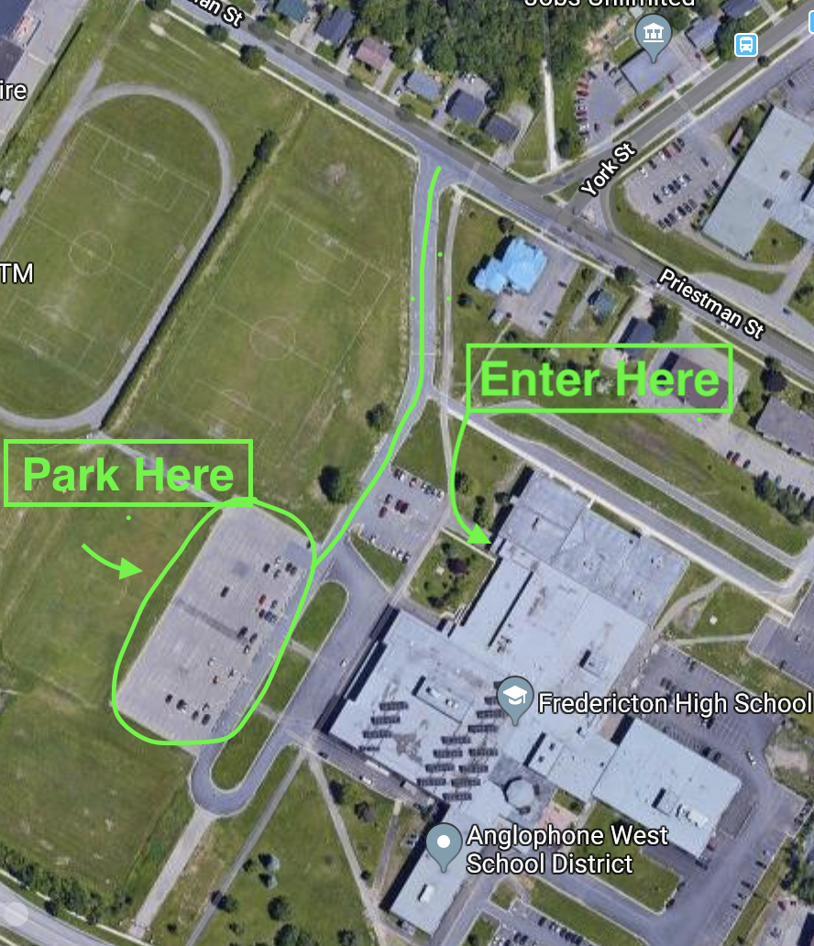
This note is to help our families with parking arrangements for our Christmas concert this Thursday, December 12, 2019 at 10:00am. Our concert location is at Fredericton High School. Please refer to the map below for parking. We will be selling tickets on our themed baskets at the concert. The draw will take place on December 18. We are looking forward to seeing you all on Thursday.

